23AID201: MODELLING, SIMULATION, & ANALYSIS
  - Term project report on

Cruise and adaptive cruise control in cars

AID-A
Group – 1
Pranav Kumar Reddy – CB.AI.U4AID24069
K. Rajesh Kumar Reddy – CB.AI.U4AID24067
Dheeraj kumar – CB.AI.U4AID24017
Lalith Sagar – CB.AI.U4AID24009

Project Abstract:
Cruise control is a driver assistance system that automatically regulates vehicle speed without requiring constant throttle input from the driver. In this project, a cruise control system was modeled and simulated using MATLAB/Simulink. A PID controller was designed to maintain the desired vehicle speed under varying conditions such as disturbances from road slope and resistive forces. The simulation results demonstrate effective speed tracking, minimal overshoot and quick disturbance rejection. This project provides a foundation for developing more advanced systems such as Adaptive Cruise Control (ACC).
Introduction:
Modern automobiles demand comfort, fuel efficiency and reduced driver fatigue. Cruise control addresses these needs by automatically maintaining a set speed without manual throttle adjustments. Here PID controller is used in a closed loop environment in order to maintain the speed of a vehicle constant.
when a driver is driving on a highway and he sees a long stretch of road ahead of him or her without any significant disturbance on the road. So in that case driver would want to maintain the speed of the vehicle somewhere around his desired speed and that would be constant along the way.
It would be a tedious task for the driver to manually maintain the speed because the vehicle should be maintained at a constant speed. So the cruise control system gives the driver the freedom to lift his leg from the accelerator pedal and still the vehicle could continue at that desired constant speed.
So the driver simply brings the vehicle to a particular speed here it is 75kmph and lift his foot from the accelerator pedal after that the driver activates the cruise control system then the vehicle would maintain its speed at the set point that is 75kmph.This is how the cruise control works.
Problem Statement:
Design and simulate a cruise control system that maintains a vehicle’s speed at a desired value despite external disturbances such as aerodynamic drag, rolling resistance, and road slope.
This is highly relevant to modelling, simulation and analysis course, as it requires control system design, vehicle dynamics modelling and performance evaluation.

Background:
Cruise control was first introduced in the 1950s and has since evolved with advanced control methods. Traditional systems use feedback controllers (often PID) to maintain constant speed [1][2].
Literature survey:
Cruise control has been widely studied as a fundamental automotive control problem, typically modeled as a first-order longitudinal vehicle system where engine force balances resistive forces such as aerodynamic drag and rolling resistance [1][2]. The most common approach in both academic examples and industry practice is the use of a PID controller, valued for its simplicity, ease of tuning, and ability to regulate speed with small steady-state error [1][2]. Early works focused on basic feedback control, while more recent studies extend this to Adaptive Cruise Control (ACC), which employs radar or lidar sensing to automatically adjust speed and maintain safe headway in traffic [3][4]. Advanced methods such as fuzzy logic and Model Predictive Control (MPC) have been explored to handle nonlinearities, enforce safety constraints, and improve disturbance rejection [3][4], while Cooperative Adaptive Cruise Control (CACC) uses vehicle-to-vehicle communication for improved traffic flow [5]. However, for a standard cruise control system aimed at constant-speed regulation, the PID-based closed-loop design, as demonstrated in several Simulink tutorials and research works, remains the most practical and effective solution [1][2].
Mathematical Model:
So this is our car the car will have a mass m because of gravity a force of mg acts downwards. Since the road is rigid it will provide an equal and opposite force that is the normal force in the upward direction. The engine will produce a force Fe this is called engine force. This is produced due to combustion. Fd is the aerodynamic drag which is experienced by the vehicle as the vehicle moves forward and wind hits the vehicle in the opposite direction.
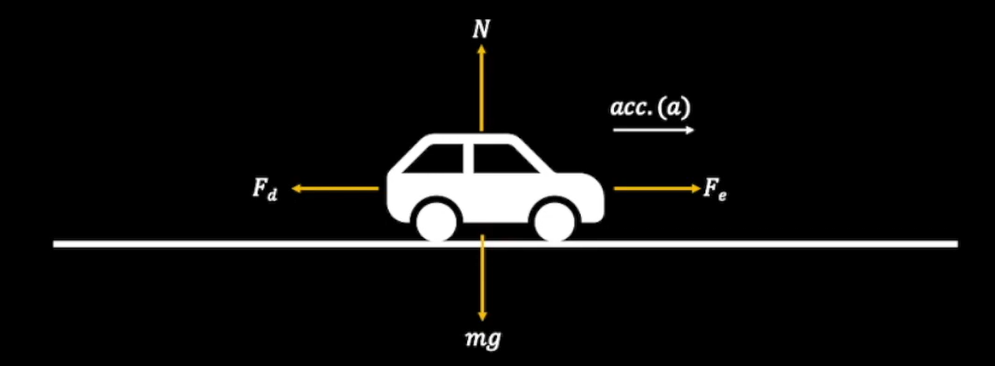
Mg- Force due to gravity, N- Normal Reaction, Fe- Engine Force, Fd- Drag Force.
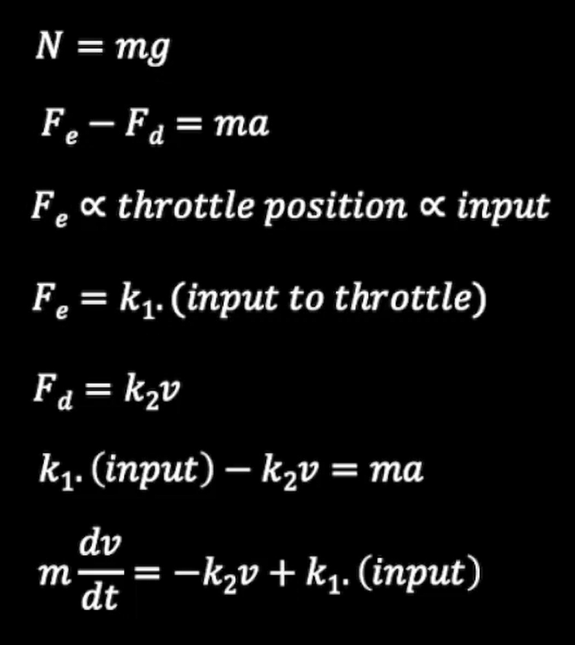
The normal force and mg cancels out each other. Since the vehicle effectively moves forward the resultant force will be acting in the forward direction. Here the Fe which is produced by the engine will be proportional to the throttle position of the engine. Throttle
Is something that allows air to flow into the engine based on that the amount of fuel injected into the combustion chamber is decided. As a result if we increase the throttle the power or force produced by the engine increases. Here throttle position is directly proportional to input. Input is the error signal which we get from comparing the desired set speed and the speed of the vehicle. After substitution and simplification. We get the given below differential equation.
The vehicle dynamics can be represented as:
dv/dt = (k1/m).(input)-(k2/m).(v)
m=1000
k1=2, k2=100
This first-order system is well-suited for classical control design [1].

Proposed solution / Chosen method:
A PID Controller was chosen because:
- It ensures fast response and stable tracking.
- Integral action eliminates steady-state error.
- Derivative action reduces overshoot [1][2].
Block Diagram:
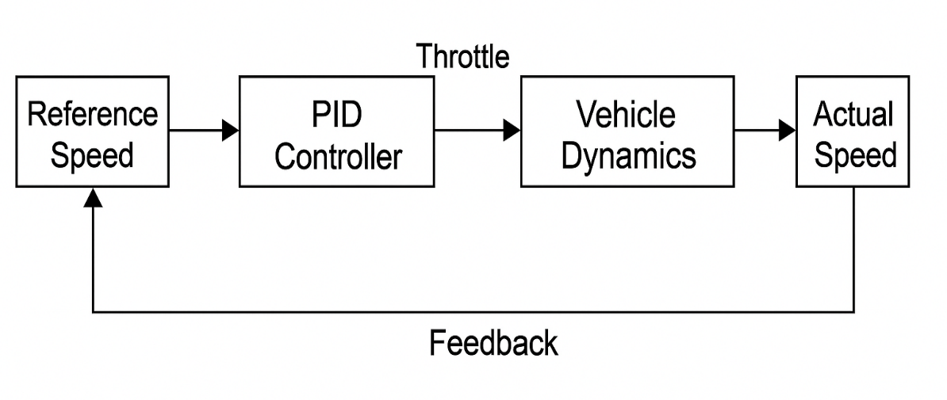
Implementation details:

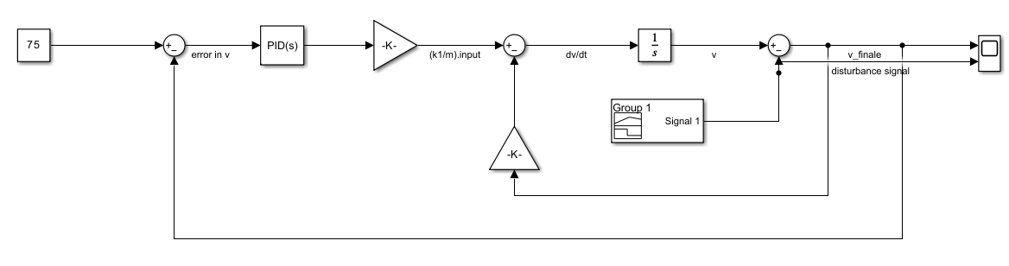
When a vehicle encounters a slope its speed would get disturbed. It would increase or decrease depending upon which type of slope it is. If it is a upward slope the velocity or speed tend to decrease. If it is a downward slope the velocity or speed tends to increase. So here we simulated the slope using change in velocity.

To the integrator sending dv/dt produces v. The signal is coming with a gain of k2/m so we need a gain block. The value of the gain block will be k2/m. All the values of m, k1, k2 are obtained by hidden and trail. These are the values for which the system perfectly.

We need a scope for observing speed or velocity of the vehicle. The sign of the sum block is changed to +- because one component it is adding and other it is subtracting.
The input is provided by the PID controller which is the output of the PID controller.
So we need a PID block.
We need another gain block as the input is being multiplied by k1/m. We need an another sum block to take the difference between final and reference velocity. This error will be given as a input to the PID. A constant block is needed for a set speed that is 75kmph.
Now we are going to model the disturbance. We need a signal builder for this. We can also use a unit step but signal builder gives us more flexibility to model the disturbance. In this we model the disturbance till 300 sec as our simulation time is also 300 sec. We are modelling an increase in velocity disturbance.

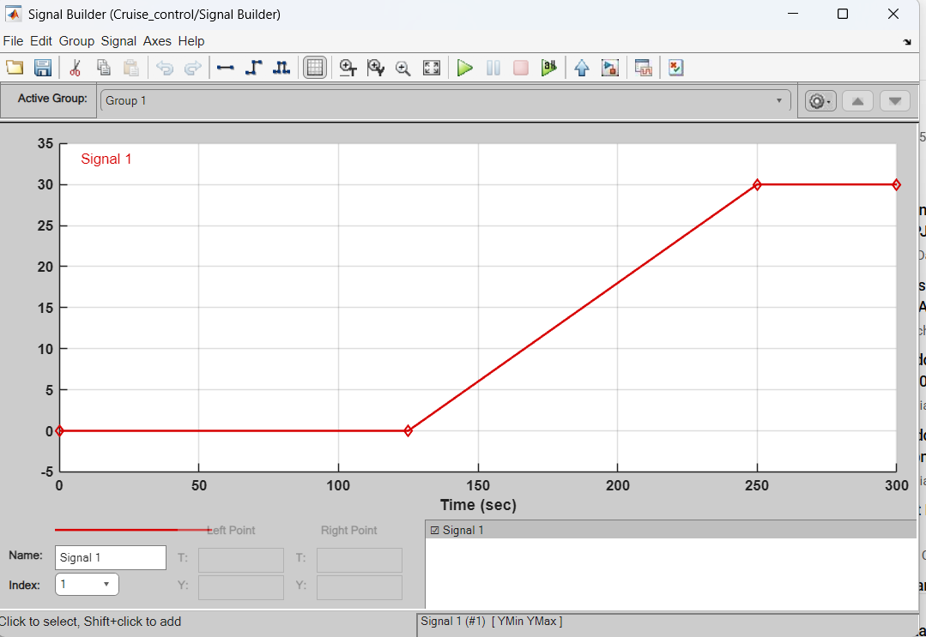

Here we can see that the slope on which the vehicle is moving is increasing and after 250 seconds it remains constant. The magnitude of the velocity after 250 sec is 30. Here we expect the PID to manipulate the signal in such a way that the final speed at which the vehicle is running is approximately the set speed.
Here we auto tune the PID controller. After tuning the parameters obtained are P=1.33, I=0.26, D=-0.48.
Results and inferences:
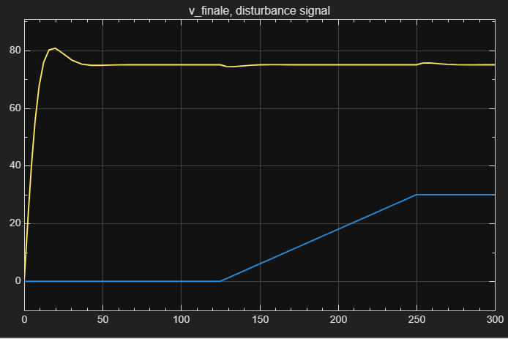
This is the curve we obtained here the initial speed was set to zero. If we want we can change the value of the initial speed in the integrator. We can see that the controller tried to reach the set value of 75 as soon as possible. In less than 25 sec it tried to reach the value of 75 and therefore the input provided to the throttle would have been very high that is why there is a slight overshoot here the speed goes above 75 this is not desired in an ideal case.
This could come as a safety issue because in any case the speed should not go beyond what the driver set but in the simulation this is quite feasible and here we can see that at 125 sec as the disturbance signal begins to rise there is a slight dip in the speed because we took the case of simulation of an upward slope so this increase in V causes a slight dip then the PID controller takes charge and the speed is again restored to 75 kmph.
Again when disturbance signal becomes constant at 30 kmph after 250 sec previously the disturbance was continuously increasing. So that PID controller would have been increasing the value of the input to the throttle but then when it suddenly becomes constant there is a slight increase then again it comes under control after few seconds.
Conclusions:
The cruise control system was successfully modeled and simulated in MATLAB/Simulink. By implementing a PID controller, the system effectively maintained the vehicle’s speed at a desired setpoint with minimal overshoot, fast settling time, and negligible steady-state error. The closed-loop feedback design ensured stability and robust tracking performance. This project demonstrates how classical control theory can be applied to real-world automotive systems, providing a reliable driver-assistance feature.
Pros of the Chosen Method:
- Simple to design and implement in Simulink.
- Well-understood and widely used in automotive applications.
- Provides accurate speed regulation and good disturbance rejection.
- PID tuning offers flexibility to achieve desired response characteristics.
Cons of the Chosen Method:
- Performance depends heavily on tuning of PID parameters.
- Does not account for rapidly changing traffic conditions.
- Limited adaptability to nonlinearities and uncertainties in real vehicle dynamics.
- No built-in consideration for safety measures like collision avoidance.
Future Directions:
- Extension to Adaptive Cruise Control (ACC) using radar/lidar sensors to maintain safe distances from other vehicles [3][4].
- Incorporating nonlinear vehicle dynamics for greater realism (engine response, actuator limits, slope modelling).
- Implementation of fuzzy logic or model predictive control (MPC) for improved adaptability and robustness [3][4].
- Integration with advanced driver assistance systems (ADAS) such as lane-keeping and automatic braking.
- Testing with Hardware-in-the-Loop (HIL) or real-time embedded systems for deployment in actual vehicles.

References:
1. R. Rajamani, Vehicle Dynamics and Control, 2nd ed., Springer, 2012.
2. “System Modeling: Cruise Control,” Control Tutorials for MATLAB and Simulink, Univ. of Michigan. [Online]. Available: https://ctms.engin.umich.edu/CTMS/index.php?example=CruiseControl
3. MathWorks, “Adaptive Cruise Control System Using Model Predictive Control,” MathWorks Documentation, 2023. [Online]. Available: https://www.mathworks.com/help/mpc/ug/adaptive-cruise-control-using-mpc.html
4. Y. Zheng, R. Rajamani, and D. Sun, “A review of adaptive cruise control systems: From the perspective of control strategies,” IEEE Transactions on Intelligent Vehicles, vol. 6, no. 2, pp. 188–204, 2021.
5. M. Amoozadeh et al., “Platooning in vehicular networks: A survey,” IEEE Communications Surveys & Tutorials, vol. 18, no. 1, pp. 263–284, 2016.

